GRAMMAR
TO BE
I am a student. I am 20 years old.
He is a doctor. You are single.
We are engineers. Amy is married.
Ali is a dentist. My brother is tall.
Suna is a housewife. Tom is 19 years old.
Burak and Ahmet are vets. My sons are 1 year old.

BE

I am from Malatya. I am happy.
Sue is from the USA. You are friendly.
Helga is German. We are tired.
My mother is at home. My friend is energetic.
We are in the classroom. The children are noisy.
The teachers are in the canteen. Allan is very sad.

- Choose the best word, a), b), c) or d), to complete the sentences.

- There _is a party tonight.
a) is b) are c) isn’t d) aren’t
- There _____ any cars in the street.
a) is b) are c) isn’t d) aren’t
- _____ there a class today?
a) Is b) Are c) Isn’t d) Aren’t
- The bank _____ opposite the post office. It’s opposite the school.
a) is b) are c) isn’t d) aren’t
- There _____ four cinemas in my town.
a) is b) are c) isn’t d) aren’t
- _____ there any people in the museum?
a) Is b) Are c) Isn’t d) Aren’t
- There _____ a cheap restaurant in the town. They are all expensive.
a) is b) are c) isn’t d) aren’t
- There _____ a fountain in the park. It’s very beautiful.
a) is b) are c) isn’t d) aren’t
- There _____ any beaches in London.
a) is b) are c) isn’t d) aren’t

- Read the texts and answer the questions.
Lake Baikal is a beautiful lake in Siberia, Russia. It is near Irkutsk and it is very, very big. It is about 30 million years old.

The New Museum of Contemporary Art is in New York in the US. It is not old (about 30 years old) but it is great. It is open from Tuesday to Sunday. Entrance is $6. | ‘Dracula’s Castle’ is really Bran’s Castle. It’s in the Carpathian Mountains in Romania. It is near Brasov and it is open from Tuesday to Sunday. It is about 800 years old. Entrance is about €2.

Lake Baikal
- Is Lake Baikal in Russia? Yes, it is.
- Is it near Siberia? No,it isn’t. It’s in Siberia.
- Is it small? No,it isn’t. It’s very, very big.
- Is it old? Yes,it is. It’s 30 million years old.
The New Museum of Contemporary Art
- Is it in the UK? No, it isn’t It’s in New York, US.
- Is it old? No, it isn’t. It’s about 30 years old.
- Is it closed on Mondays? Yes, it is.
- Is it free? No, it isn’t. It’s $6.
Bran Castle
- Is Bran Castle in Romania? Yes,it is.
- Is it near Bucharest? No, it isn’t It’s near Brasov.
- Is it open on Mondays? No, it isn’t. It’s open from Tuesday to Sunday.
- Is it free? No, it isn’t. It’s about €2.
- Order the words to make questions.
- your / ‘s / name / What
__What’s your name_________________?
- She / Where / ‘s / from
__Where’s she from__________________?
- America / from / they / South / Are
__Are they from South America_______?
- five / room / we / in / Are
__Are we in room five________________?
- holiday / you / Are / on
__Are you on holiday_________________?
- from / he / Poland / Is
__Is he from Poland__________________?

- Match these answers to the questions in C.
- Yes, he is. __(6)___
- No, I’m not. __(5)___
- She’s from Italy. __(2)___
- No, we aren’t. __(4)___
- Yes, they are. __(3)___
- Michael. __(1)___

VOCABULARY
KEY LANGUAGE
- Look at the map, read the text and fill in the blanks with the correct preposition in the box.
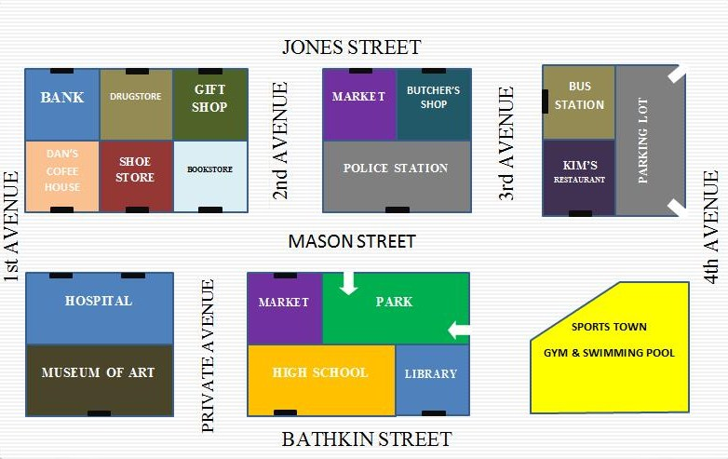

next to(x2) between on (x3) opposite on the left on the right

The hospital is 1) ___on___ Mason street 2) __opposite__ Dan’s Coffee House. The butcher’s shop is 3) __on__ Jones Street 4) __next to__ the market. The Shoe Store is 5) __on__ Mason Street 6) __between__ the bookstore and Dan’s Coffee House. Kim’s restaurant is on the corner of 3rd Avenue and Mason Street 7) __next to__ the parking lot. The bank is 8)__on the left__ of the map.Sports Town is 9) __on the right__ of the map.

- Match the words in the box with the pictures.

an airport | a museum | a beach | a bridge | a church | a fountain | a concert hall | a temple | a harbour

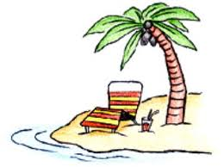  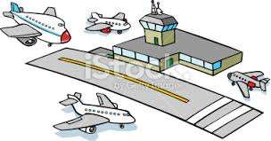  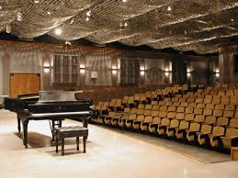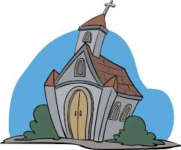 | 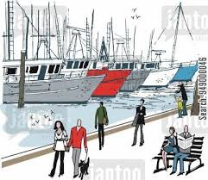  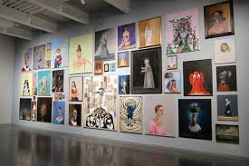
- Write the opposite adjectives.

- London isn’t cheap. It’s __expensive__.
- My coffee isn’t hot. It’s ___cold___.
- ‘Are your shoes new?’
‘No, they’re ___old____.’
- You aren’t a bad student! You’re a ___good__ student.
- ‘My Dad’s 40. He’s old.’
‘He isn’t old! Forty is ___young___.’
- These students aren’t noisy. They’re __quiet___.
- Our flat isn’t big. It’s ___small___.
- The weather isn’t dry! It’s ___wet___.

